Your Excellency,

We want to express our deep gratitude for your concern about Eucharistic revival. Thank you, Bishop, for your love of God and this central dogma of our Faith.

This is the something that, as parents, we have thought a lot about for the sake of our children. We are writing this letter to you because we are your faithful children, and we hope in your pastoral and fatherly love for your sheep.

We wish to express to you some of the motivations for seeking to have the Latin Mass for our children’s formation in your diocese. We thought a good way to illustrate our concern is to express it in this chart:

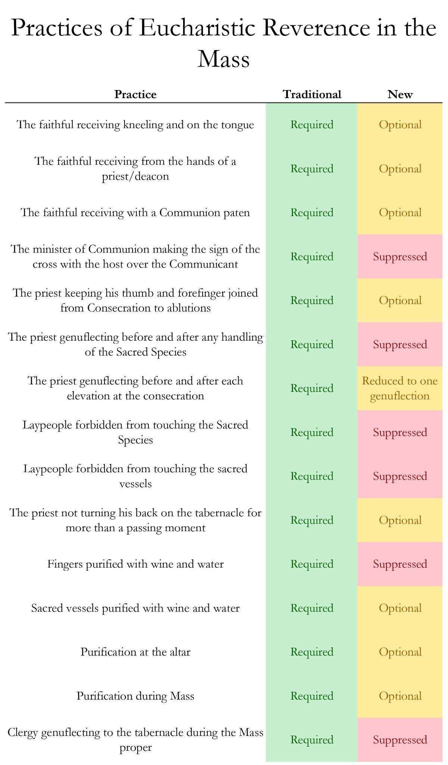
We want to emphasize here two important things: none of us questions the validity of the New Mass, nor the validity of the Second Vatican Council. We just want to be faithful Catholics and raise our children in the Faith. But this chart illustrates some of the reasons why we are trying to have the Latin Mass for our children.

As parents, we know the profound psychological effect on our children – long before their first Communion! – of seeing their parents kneel and receive Our Lord on the tongue. Or when they are catechized to know what the consecration is – they see the priest do what we should all do to greet the King – immediately genuflect!

But in considering Eucharistic revival, we think of three separate points:
- In the midst of a major crisis of Eucharistic faith and devotion, we are trying to increase faith and devotion in the Most Holy Eucharist.
- Lex orandi, lex credendi. The law of belief is primarily determined by and housed in the law of prayer.
- The traditional Mass contains more acts of Eucharistic piety than does the New.

The conclusions to the above points are readily apparent.

Only the traditional Roman Rite requires all of these practices which are otherwise optional or even illegal. Therefore, as an important means for Eucharistic revival, we ask you to promote the traditional Mass for the sake our children, or at least to allow us to promote it ourselves:
- In order to fulfill our goals contained in point #1.
- In conjunction with the laws of human nature in point #2.
- In recognition of the facts in point #3.

We hope, in your pastoral love and concern for manifesting a “listening Church,” that you will truly hear the concerns of the sheep.

If you would like to write back or have a meeting of dialogue with us about this, we would be delighted to hear from you and to talk more. Please contact us at ____.

Faithfully your children in Christ,

NAME
NAME
NAME
NAME

